WEEK-2

**Logging using SLF4J**

**Exercise 1: Logging Error Messages and Warning Levels**

LoggingExample.java:

package com.example;

import org.slf4j.Logger;

import org.slf4j.LoggerFactory;

public class LoggingExample {

    private static final Logger logger = LoggerFactory.getLogger(LoggingExample.class);

    public static void main(String[] args) {

        logger.error("This is an error message");

        logger.warn("This is a warning message");

    }

}

pom.xml:

<project xmlns="http://maven.apache.org/POM/4.0.0"

         xmlns:xsi="http://www.w3.org/2001/XMLSchema-instance"

         xsi:schemaLocation="http://maven.apache.org/POM/4.0.0

                             http://maven.apache.org/xsd/maven-4.0.0.xsd">

    <modelVersion>4.0.0</modelVersion>

    <groupId>com.example</groupId>

    <artifactId>LoggingDemo</artifactId>

    <version>1.0-SNAPSHOT</version>

    <properties>

        <maven.compiler.source>11</maven.compiler.source>

        <maven.compiler.target>11</maven.compiler.target>

    </properties>

    <dependencies>

        <!-- SLF4J API -->

        <dependency>

            <groupId>org.slf4j</groupId>

            <artifactId>slf4j-api</artifactId>

            <version>1.7.30</version>

        </dependency>

        <!-- Logback Classic (SLF4J implementation) -->

        <dependency>

            <groupId>ch.qos.logback</groupId>

            <artifactId>logback-classic</artifactId>

            <version>1.2.3</version>

        </dependency>

    </dependencies>

    <build>

        <plugins>

            <!-- Exec plugin to run main class -->

            <plugin>

                <groupId>org.codehaus.mojo</groupId>

                <artifactId>exec-maven-plugin</artifactId>

                <version>3.0.0</version>

                <configuration>

                    <mainClass>com.example.LoggingExample</mainClass>

                </configuration>

            </plugin>

        </plugins>

    </build>

</project>

**Output:**

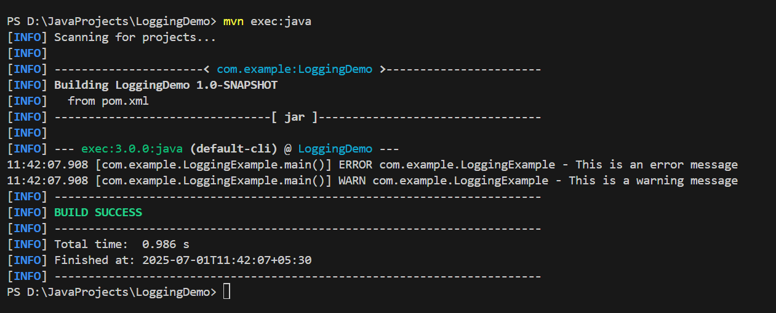

**Exercise 2: Parameterized Logging**

ParameterizedLoggingExample.java:

package com.example;

import org.slf4j.Logger;

import org.slf4j.LoggerFactory;

public class ParameterizedLoggingExample {

    private static final Logger logger = LoggerFactory.getLogger(ParameterizedLoggingExample.class);

    public static void main(String[] args) {

        String userName = "Vineela";

        int loginAttempts = 3;

        boolean isLocked = true;

        logger.info("User {} has attempted to login {} times", userName, loginAttempts);

        logger.warn("Account locked status for {} is {}", userName, isLocked);

        logger.error("Failed login for user: {} after {} attempts", userName, loginAttempts);

    }

}

Pom.xml:

<project xmlns="http://maven.apache.org/POM/4.0.0"

         xmlns:xsi="http://www.w3.org/2001/XMLSchema-instance"

         xsi:schemaLocation="http://maven.apache.org/POM/4.0.0

                             http://maven.apache.org/xsd/maven-4.0.0.xsd">

    <modelVersion>4.0.0</modelVersion>

    <groupId>com.example</groupId>

    <artifactId>LoggingDemo</artifactId>

    <version>1.0-SNAPSHOT</version>

    <properties>

        <maven.compiler.source>11</maven.compiler.source>

        <maven.compiler.target>11</maven.compiler.target>

    </properties>

    <dependencies>

        <!-- SLF4J API -->

        <dependency>

            <groupId>org.slf4j</groupId>

            <artifactId>slf4j-api</artifactId>

            <version>1.7.30</version>

        </dependency>

        <!-- Logback Classic (SLF4J implementation) -->

        <dependency>

            <groupId>ch.qos.logback</groupId>

            <artifactId>logback-classic</artifactId>

            <version>1.2.3</version>

        </dependency>

    </dependencies>

    <build>

        <plugins>

            <!-- Exec plugin to run main class -->

            <plugin>

                <groupId>org.codehaus.mojo</groupId>

                <artifactId>exec-maven-plugin</artifactId>

                <version>3.0.0</version>

                <configuration>

                    <mainClass>com.example.ParameterizedLoggingExample</mainClass>

                </configuration>

            </plugin>

        </plugins>

    </build>

</project>

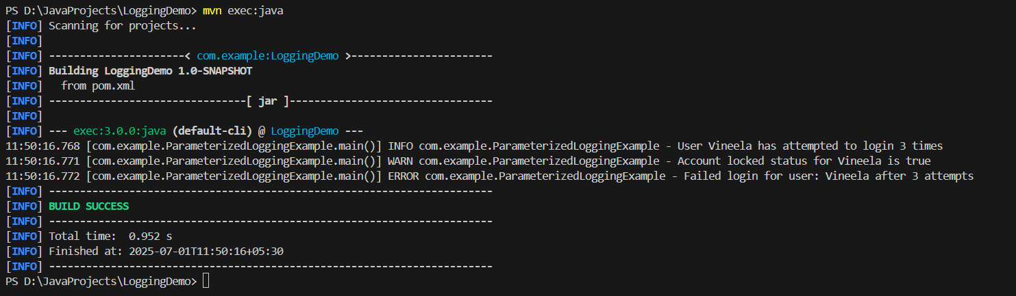**Output:**